LOGGING IN SPRINGBOOT

Logging in springboot application is implemented with the help of the logging framework

Now we have some microservices and in order to complete one complete transaction we need to move from one microservice eto the other hence sleuth will help us in logging the whole flow so that we can come to know where the issue lies

As in the above example the google pay service is talking to bank service but bank service is down.

But bank service has two instamces 909 and 9091 so we need to identify which of the two has a problem so we will implement zipkin

**HOW ZIPKIN HELP US TO TRACK THE REQUEST FLOW?**

If we add sleuth and zipkin in our microservice then for each request sleuth will have metadata which will have the below:

Service name will be the name of the service and trace id will remain same throughout the microservices for a particular request

And span id is unique id per microservice

**For loging purpose we wil be using the zipkin**

**1.first of all we need to install zipkin from the official document**

**2.Now we need to run the zipkin server which will be running on 9411 port**

We need to go into the folder where we have kept the zipkin server jar.Also make sure you have the jdk installed in your system because to run the jar we would need the jdk.

Nw when you open the cmd add the below command

**C:\Users\aayushi.bansal\Desktop\CASE STUDY>java -jar zipkin-server-2.24.1-exec.jar**

Zipkin will run on port 9411

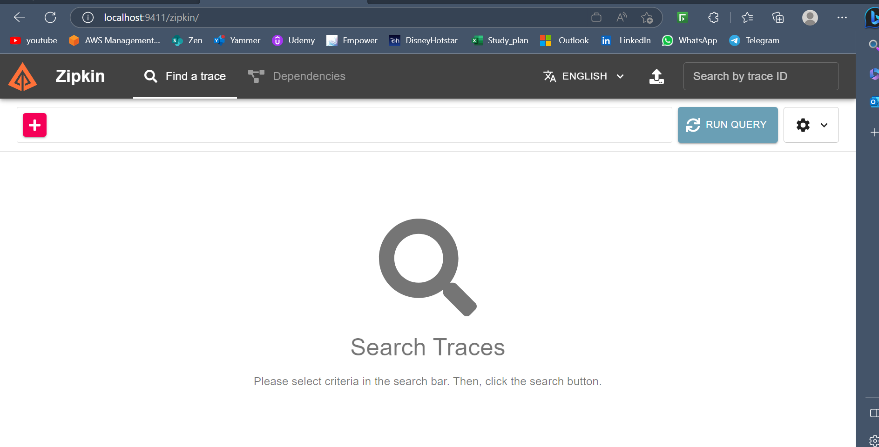

**3Now we have a user service whom we need to centrally log so we will add the zipkin and sleuth dependenciesn to it.**

We have to register our microservices on the zipkin server.We will add the zipkin and sleuth dependencies to the microservices whom we want to get centrally logged so that they can register themselves on the zipkin server

<dependency>

<groupId>org.springframework.cloud</groupId>

<artifactId>spring-cloud-starter-zipkin</artifactId>

<version>2.2.8.RELEASE</version>

</dependency>

<!-- https://mvnrepository.com/artifact/org.springframework.cloud/spring-cloud-starter-sleuth -->

<dependency>

<groupId>org.springframework.cloud</groupId>

<artifactId>spring-cloud-starter-sleuth</artifactId>

<version>3.1.8</version>

</dependency>

A

**4.now in our application.properties we wil specify the address of zipkin**

Now w e neeed to tell addresss of zipkin server so that all services can push logs there.

spring.zipkin.base-url=http://localhost:9411/

spring.zipkin.base-url=http://localhost:9411/

5.now we will run our application and we will be able to see our logs